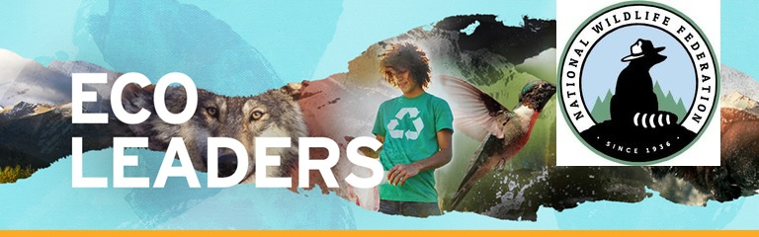
National Wildlife Federation's EcoLeader Initiative

Building and Connecting the Next Generation of Wildlife and Conservation Leaders Through Community.
College and University students today are the first generation to grow up experiencing the obvious changes to the planet. Seeing these changes first hand makes us yearn to help - to create greener campuses, advocate for clean-energy policies, and find a sustainable way to live. NWF wants to help develop the leadership skills and environmental knowledge of students to help them on their mission to preserve a livable planet.

EcoLeaders Initiative
The EcoLeaders initiative draws almost 30 years of experience working to make colleges and universities more sustainable. It is the first web-based initiative to provide students the virtual space to initiate projects on their campuses, network with students across the country, and earn recognition for their sustainability leadership. EcoLeaders provides opportunities to engage in environmental projects, and find the support, knowledge, and best practices needed so that projects succeed, projects such as conducting energy and water audits on campus, developing on-site recycling, promoting sustainable food purchasing, and more.
Join the more than 1300 currently registered EcoLeaders and use our platform to:
- Plan, launch, and recruit others to join sustainability projects
- Join forums to discuss environmental topics
- Access resources to support efforts on campus and build leadership skills
- Earn certifications that can be applies to course requirements, resumes, and social media.
View current projects and register as an EcoLeader today: NWFEcoLeaders.org
Questions? Email ecoleaders@nwf.org

