Nepris_Poetry&Professions_Compression_180319_v1

Could YOU Be a Poet?

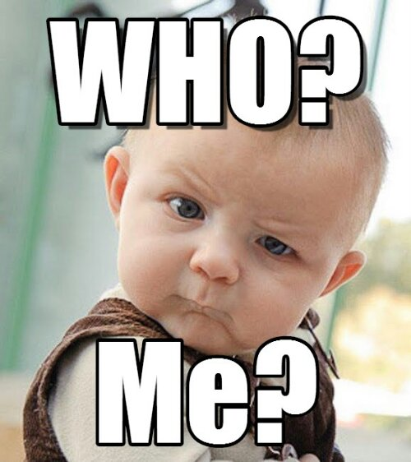

Yes,

YOU!

Ask yourself: Could you

* Enjoy playing with language a lot—for the next 30 years?
* Write thousands of incomplete or just crumby poems, plus fifty or sixty pretty good ones?
* Learn to appreciate criticism from people who don’t bother to try to understand you?
* Develop a good attitude about journals rejecting your work—especially the GOOD POEMS?
* AND DO ALL THIS, BASICALLY, FOR FREE?

If you answered “Yes” to all these questions, then YOU could be a POET!

But what if I like poetry and playing with language, but I don’t want to feel insulted and neglected all the time? What if I want to do something that earned a living wage?

Well, not many poets ever get **paid** for their work, even as teachers.

BUT many of the skills that a poet develops can be useful in REAL JOBS! (--that includes teaching!)

One skill could be called COMPRESSION, which is a kinda fancy way of saying a good poet has the ability to SURPRISE.

You’ve learned a bunch of ways of explaining what Poetry is. Well, here’s another one!

POETRY is an ART in which we set up people’s expectations and then DISAPPOINT them. We let them think they’re Oh-so-clever! And then we pull the rug out from underneath them! But it’s okay because they’ve been trained to think that our ability to TRICK them doesn’t show how gullible they are. No! They think they got tricked because WE’RE GENIUS POETS!

Really though, most of a poet’s tricks are easy enough for a baby to see through. USE STRAGEDY!—(I mean, STRATEGY!)

1. Set up a pattern that they recognize, so they feel smart enough to follow along and let their dumb brains go back to sleep.
2. Then—WHAMM!—hit them with a trick that shows they expected wrongly!

*Roses are red*

*Violets are blue*

*Thoughts of you in my head*

*Make me think* MY SKULL IS GONNA EXPLODE IN A SHOWER OF BLOOD AND BRAINS!

This demonstrates how rhythm and rhyme set up expectations—just so that the theater is quiet when the super-smart poet sets off the fire alarm.

We find

--Familiar rhythm and rhyme creating expectations.

--Then the poem’s meaning suddenly shifting, “Roses are Red” is a cliché of simple *LURVE POESIE*. Most people don’t associate cutesy love with exploding heads, and blood and brains going all over the audience’s nice slacks and skirts. If they *did* expect head explosions, this poem wouldn’t be very surprising. It might be a very familiar, sad, tragic poem. AND we would all be very afraid on Valentine’s Day.

Another way that Master-mind Poets create surprise and wonder in the brains of people easily fooled is by employing the secret weapon of FIGURATIVE LANGUAGE. You know this baby trick already. But the key to figurative language is that it pulls a fast move: it makes a swerve or a ‘turn’ in how people are thinking. For instance, look at the secret powers of SIMILE and METAPHOR.

Right! SIMILE uses “like” or “as” connecting phrases to make an IMPLIED comparison between DIFFERENT THINGS.

*My Ford Fusion is like unto my mother’s Chevy Malibu.* In fact, it used to be my mother’s Fusion, but she liked the Malibu better. So she gave me the Fusion [BAD SIMILE! Those cars are produced by different companies, but they’re basically the same. Even worse, this wanna-be poet just explained what the similarity is. That’s like telling why a punch-line is funny. DUFUS!]



*My Ford Fusion is like a magic carpet that levitates down peaceful highways through a cloud of butterflies into a shower of sunshine.*

[Okay. This is more like a working SIMILE. At least we have to read between the lines. This poet feels like his mom’s old Fusion is a magical vehicle that carries him through a beautiful highway system filled with peaceful wildlife and happy sunlight. It’s a nice feeling! Everybody knows poems are about nice feelings! –Nuh-uh! That’s not always true. In fact, if we always think poetry is nicey-nice, then a SIMILE that says “My ride is nice because it makes me feel nicey-nice and think of nicey-nice things” isn’t making a surprising CONTRAST. So, okay, the SIMILE makes sense with similarity, but the things it highlights fit people’s expectations about what poetry is supposed to sound like. If you always set up expectations and then SATISFY them, people will think your poetry isn’t surprising. It’s what anybody’d expect. {*Yawn*} It could be boring.]

We gotta set them suckahs up! Then we break all their little expectations!

*My Ford Fusion is like the Fourth Horseman of the Apocalypse to any squirrels and chipmunks foolish enough to stray on the asphalt as I come barreling down the highway doing ninety like a jet angel of rodent-destruction!*

[BETTER! I’ll bet that most readers don’t ordinarily identify a seventeen-year-old in a Ford Fusion with Death personified—even as the nemesis of small woodland creatures! But, notice, that expectations can go both ways. Yes, because deep-down troubled teenagers wish they could casually decide the fates of all mortals according to their omnipotent whims {Crazy disturbing teenage laughter: Hahh-hah-ha-ha-haaaa!}, we get a comparison that is not very much like the nice comparisons that similes usually make. So maybe this simile will fox other poetry people!

But it’s a game of contrasts that can be played both ways.]

*My Ford Fusion is like the Fourth Horseman of the Apocalypse because, though I’m the Inescapable Eliminator of chipmunks, I love my car sooo dearly, and I wash it and wax it and care for it much as DEATH washes and combs and braids the long pink mane of his dire but* ***adorable*** *death-pony!*

[See! Just because this poet set up a bunch of seventeen year-olds who love Anthrax and Black Metal to get all enthusiastic about the *dark poetry*, she totally bamboozles and confoozles them by turning their expectations of death-and-chipmunks into thoughts about *My Little Pony*. Those dark metal doods are all up into rodent massacre, but they haven’t considered that the wickedly unassailable person of DEATH has deep adoration for his pink-maned pony!

Our expectations lead us down strange paths, but our brains are made to keep up—wherever the poem is going. That means we can work as an audience to keep up with the poet and then find ourselves in a bunch of meanings that aren’t familiar and aren’t comfortable. Surprise! Then the poet doffs her hat because she took a bunch of guys with death-tattoos into My-Little-Pony world.]

Okay. So the moral here is that SIMILE can work a little or it can bring big payoffs, but it’s all about whether the poet can lead the audience—No, SUCKER the audience—into buying into a connection between things they TOTALLY DIDN’T EXPECT.

That rule goes DOUBLE for METAPHOR. Let me tell you WHY. Then let me tell you REALLY WHY.

WHY? Because METAPHOR is a construction of the SIMILE that just takes out the “like” or “as” connector. BUT EVERYBODY KNOWS THAT METAPHOR is just a slightly more compressed—more surprising—way for a poet to suggest that things that are different are similar in special ways. Let me show you!

*My Love is like a red, red rose*. **=** *My Love is a red, red rose*.

It’s perfectly reasonable. “My Love is . . .” is a shorter way of saying “My Love is like . . . “

*My Love is*/ *is like* **because** . . . [he] is beautiful.

. . . [she] smells delightful.

. . . [he] is so fresh, young and blooming.

. . . [her] skin is soft as petals.

. . . [his] toes are so supple to my touch.

Enough! Yeah, there’s your usual argument that straight METAPHOR is a shorter version of SIMILE, which tells the audience that a comparison or contrast of different things is being implied.

NOW LET ME TELL YOU HOW SIMILE AND METAPHOR REALLY RELATE!

SIMILE clearly says—with “like” or “as”—that the poet draws attention to some kind of similarity between things, some sort of comparison.

But METAPHOR literally argues that TWO DIFFERENT THINGS ARE THE SAME THING. My friends, you’ll meet a million readers who say this is an extreme and unreasonable interpretation. And yet, we all live with the REALITY of metaphorical IDENTITY and EQUALITY every day. The ease with which we see citizens in a state, employees in a corporation, particles in an atom, and moods in a personality is a creation of FIGURATIVE LANGUAGE central to how we understand the world. **What the heck is this supposed to mean?**

*Example 1.* A Dollar bill is one-hundred pennies.

--So “Ten one-dollar bills are one-thousand pennies.” Sure. Now go buy a loaf of bread, a carton of milk, and a pack (On Sale!) of Nabisco’s Oreos for just under $10.00. Then take your bag of one thousand pennies and start counting-and-shifting them over to the dood at the cash register. People looked at you funny when they saw you drop a bag of one-thousand pennies in your cart. Now they’re looking *mean* as you prove to them you intend to pay for a $9.97 bill in pennies.

*Well, currency notes and coins equal the same thing.* Carry a sack of one-thousand pennies up to the check out and then tell me that the crazy mound of copper is the same thing as one crumpled paper bill.

So how serious is this “power” of figurative thinking with metaphor?

*Example 2:* 1 + 1 = 2

Really? Multiple things are the *same* thing as single things?

*Example 3:* “Hey, you and I are different, but we’re still just people.”

What the heck does that mean? Are we talking about physiology? About animal species? I have a head and four limbs, like you. We’re “people.” Chimps are not people like us? What basic level of peoplehood do we share?

I’m not trying to diss metaphor. I’m trying to show that the “suprises” created by figurative language get forgotten. They stop being “surprising.” They start to be “just true.” That’s how important figurative language—and poetry—become to human understanding. If logic were absolute, we’d never get anywhere. The **\*moment\*** that just happened is different from the **\*moment now\***. Nehh, I say, they’re pretty much the same, though I’m thinking about something else now, and in the time it’s taken me to type this, people have been born and have died. It’s all the same to me, but I dismiss all the evidence that **that** moment and **this** moment are very different.

What’s the MORAL of all this?

POETRY demonstrates that we like things we can expect and count on, but they can bore us. POETRY demonstrates that we love things that are surprising, but we need our metaphorical surprises to calm down, to get with the program, and to become nice clear EQUIVALENCES that are different but are PRACTICALLY the same. Well, logically, how do two things become one thing? How does what just happened remain identical to NOW? There are “kinds of logic” that well all trust and count on. BUT REALLY, HUMAN FEELINGS ARE THE CONNECTORS THAT MAKE OUR METAPHORS—NOT FICTIONS, BUT FACTS.

**Dear Mr. Manny. You implicitly argued that by not setting my sights on becoming a professional poet, I’d find ways of getting a real job with salary. Would you please get to the point where you explain how I can use my skills of poetic trickery to get proper employment?**

Yes. Let me do that.

Quick bit of history: for thousands of years, philosophers and scientists have been giving ordinary people (like me) logical proofs that THIS is simply TRUE. Many of us ordinary people have not agreed with plain logic. We have said that we can see how a claim is supposed to make perfect sense. But it doesn’t feel right. We accept that it *might* be so, but we really don’t believe the new argument.

One of the old Greek philosophers argued that wise people couldn’t rely on the clear proofs of their arguments to sway their audiences. People usually aren’t logical thinkers. They’re more inclined to go with what they *think* they know or to side with what their aroused emotions tell them is what’s up.

That old philosopher was Aristotle. He was a student of Socrates and Plato, but, unlike his teachers, Aristotle was really super interested in the unique details involved in each art and science. Yes, he was a sort of a genius. No, he was often just incorrect in what he claimed. But he wrote what was a monumental book on nearly every subject. He wrote the *Poetics*, first systematic guide covering how to do poetry, theater, long stories like novels (epics) and comedy. He was also the first classical author to write a systematic book about how political systems work. And he wrote a wonderful, puzzling, but useful book about how *We* connect to political society with our ideas and feelings—his *Rhetoric*.

*Rhetoric is”the faculty of observing in any given case the available means of persusasion.”* Aristotle said that really smart people might understand everything rationally: they’d accept that a buck is the same thing—pretty much—as one-hundred copper pennies. But society needs people who can get large numbers of strangers to agree to reasonable arguments, even if the arguments are over their heads. Even if the arguments are boring. Even if people would just prefer to believe what they already feel like they know certainly.

Aristotle wrote the Book on how to win arguments and persuade people. He said that arguments and linguistic performances stirred peoples’ emotions. Like Poetry. He wrote the first book on how poetry works too.

Poetry creates one sort of art. Rhetoric—the art of convincing people—doesn’t create anything in particular. But it’s central to advertising, to politics, to public relations between businesses, and to diplomacy between countries. In fact, as our civilization gets closer to empowering technological systems that change how humans interact, the need grows to employ skilled people who can help ‘users’ and ‘customers’ understand what is happening by “any [. . . ] available means of persuasion.”

Let’s take my word for it, for the moment. Our society’s way of “arguing” about what’s true rarely depends on just words. Very often it also requires visual aids to work.

OSHA, the U.S. Office of Occupational Safety and Health Administration, issued this quick instruction to workers who were celebrating their summer vacations but who might be exposing themselves to heat-stroke:

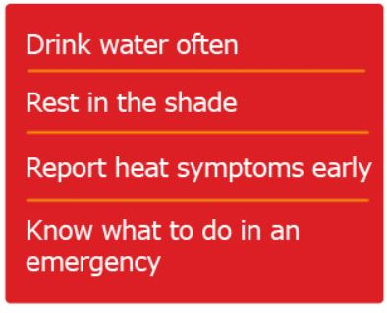

Some of us might say, “I dunno. I probably need more information and details to understand what each of these commands means.”

A lot of us will be secretly thinking to ourselves, “This set of rules is vague and boring as crud.” Aristotle, and many other logic-loving philosophers for 2,000 years, would have said that the advice was sound but it didn’t appeal.

What it needs is an advertiser’s skill with words and awareness of expectations. Or, maybe, a poet’s.

Contrast the OSHA advisory with this communication on Instagram from the U.S. Consumer Product Safety Commission (the USCPSC):

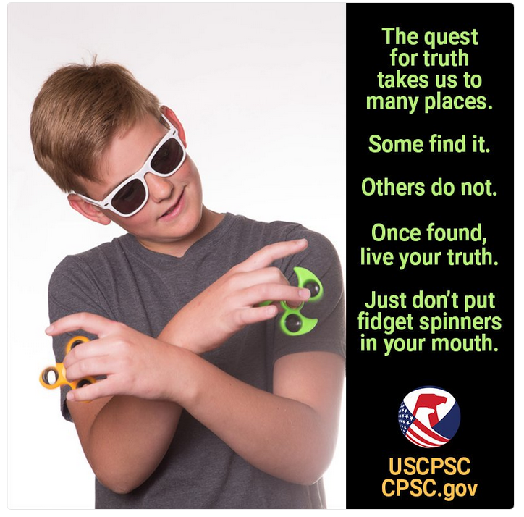

QUESTION: How does this Public Service Announcement set-up an expectation about what it pretends to be saying, and then how does it lay the fools down (defeats audience expectation)? OR what makes this funnier and more memorable than OSHA’s advice.

Okay, try this new example. Tell me: is it appealing to an explicit direction to convince the audience? Or is it appealing to a stronger, implied argument that appeals to the audience’s emotions? [CLUE: Hey, kids, if it’s FUNNY, then it must be implying something without saying straight-out what it means.]

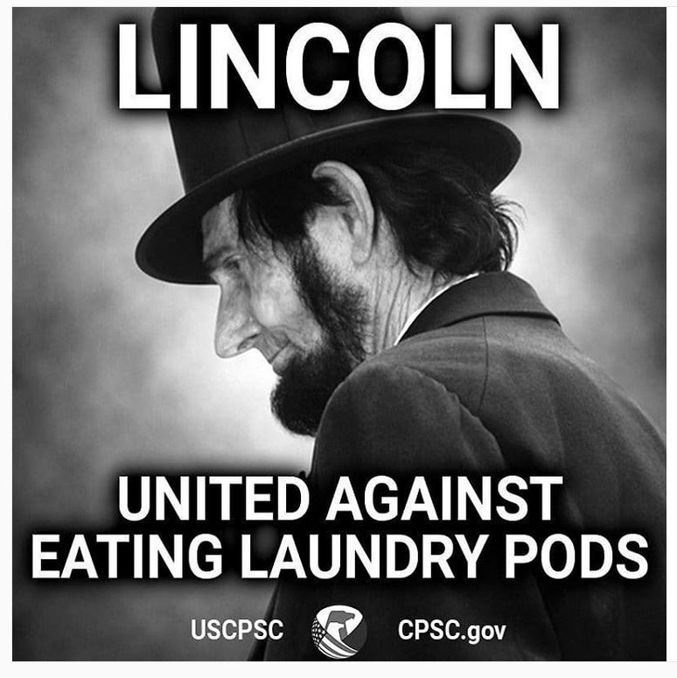

Okay, you tell me. Does this advertisement (PSA) mean precisely what it says? [Or does it imply something extra is serious, and something else (by comparison) is stupid?]

Do you see the metaphors working in these advertisements for public safety? The metaphors are jokes—total goof-offs—but they’re more memorable and so persuasive than just saying “Don’t do it! Because I just said so!”

Try this one:

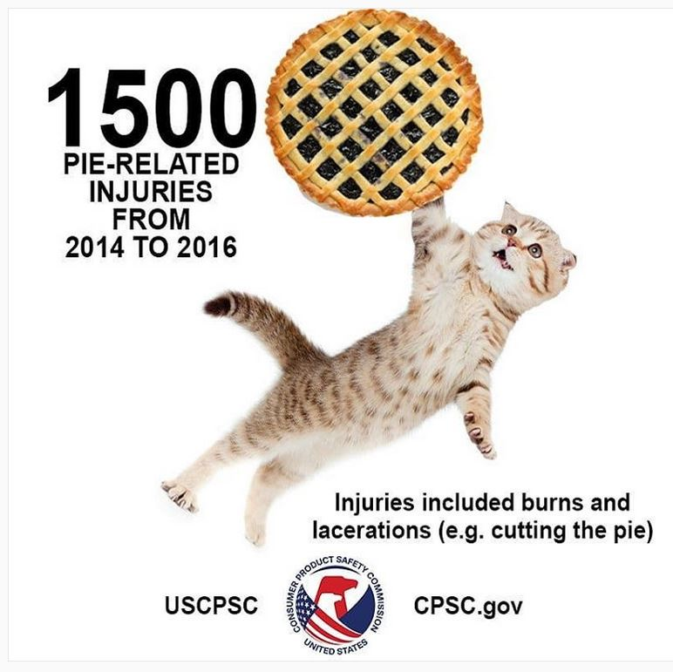

What is this message in the shortest sentence you can create? Work with variants of this sentence: “Watch out! BLANKS are BLANK!!!!” *This* advert says (literally) that we should take the experiences of a BLANK seriously?

What about this one:



Your government is telling you to look at the picture and recognize that YOU NEED TO REPORT UNSAFE CHAIRS! Literally, what is the picture telling us about how “unsafe chairs” threaten weird dudes who are hiking in the mountains?

Okay. This is the same Public Service Announcement (PSA), right? I mean, it has the same slogan. But is its dramatic story (a metaphor relating one *unlike* thing to another *unlike* thing in a funny way) the same story as the mountain-hiking ad? What is the literal story told about the woman warrior in the ad?



What hideous creatures are temporarily defeating this powerful, battle-hardened woman knight? What is unexpected (given ordinary expectations) about the picture’s narrative?

NOW consider this text box:

Report unsafe chairs on SaferProducts.gov

Which message makes a bigger impression? Which is funnier? Which will be remembered?

**I’VE GOT MY FIDGET SPINNER IN MY MOUTH**: Thus ends this lesson in poetics, like the breeze lifting the pink hairs on death’s pony. I hope I have persuaded you all to pursue poetic practices and writing but not to rely on any of it providing gainful employment. But I also hope you see that the “dirty secret” of poetry is that it operates as a very artsy form of rhetoric. And, young womyns and mens, there’s a pile of paying work out there for people who can create powerful, memorable, funny and tragic memes that help the audience remember messages. Don’t forget it!

As my last gift, I offer a Public Service Announcement from a remarkable poet who cared deeply for your safety. As you leave the classroom, you might want to grip your teacher’s hand, just to be sure that you’re safe. ;)

--Hilaire Belloc, “Jim: Who ran away from his Nurse, and was eaten by a Lion” (1907)

