IT IS NEVER SAFE TO LOOK AT THE SUN WITHOUT PROTECTION AT ANY TIME WHEN ANY PART OF THE BRIGHT DISK IS VISIBLE

- Viewing at 100% coverage, when the moon fully blocks the sun, is okay.
  - This only occurs over a narrow pathway
  - This only occurs for a minute or two at most
  - Anything less than 100% total coverage REQUIRES the use of safety glasses.
- Improper viewing can lead to “Eclipse Blindness.” This is caused by retinal burns, or damaging of the tissue at the back of the eye. (The retina has no pain receptors, and visual effects do not occur until at least several hours after the damage is done.)
  - The lense in the human eye focuses the light to the back of the eye, similar to how a hand lense with a middle schooler will cook bugs on a sunny day.
- Never point a telescope at the sun without a solar filter.

How to View:

- Use one of the following, which will block all UV light and 99.999% of visible light:
  - Eclipse Viewing Glasses -- inexpensive and specially made
  - Number 14 Welder's Glass
  - Pinhole Viewing Box or Pinhole Viewer
  - Use ONLY solar filters SPECIFICALLY DESIGNED to view the sun
- DO NOT USE SUNGLASSES (Eclipse glasses block about 1000x more light)

Where/When to View:

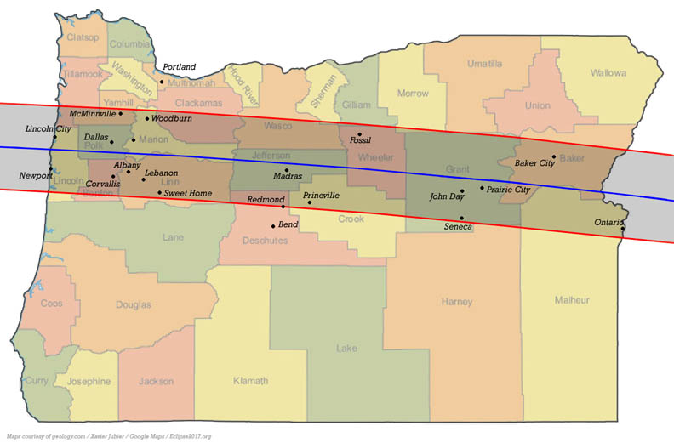
- Anywhere in Oregon on August 21st between 11:00 am and 1:30 pm Pacific Daylight Time (PDT) approximately
  - The totality is a narrow band, but the rest of Oregon (and all of Washington!) will experience 90% coverage.
- Depending on location, the totality lasts about two (2) minutes, and will occur somewhere between 12:15 and 12:30 pm PDT.
- For specific details on local times: http://www.eclipse2017.org/xavier_redirect.htm

Eclipse Viewing Safety Resources: https://sunearthday.nasa.gov/2012/transit/viewing.php

